



**St. Joseph Feast Day Information: March 20, 2023**

Today is a day to **CELEBRATE** our holy patron, St. Joseph! Ideally, most of the day will include activities and lessons of some sort that have a connection with our patron. Let us praise the Lord for the gift of St. Joseph and our school family!

* **Attire:** Dress up in your finest dress clothes in honor of our holy patron, Saint Joseph!

(Dress pants/shirts for boys and skirts/dresses for girls are encouraged. Modest necklines and length to the knee are expected. Pants should be loose fitting. Shoes should be comfortable and usable for recess. Uniforms are still welcome. Additionally, girls could style their hair and boys can wear ties. Sorry, no nail polish.)



* M**ass:** 5A Class Mass
* **Litany of St. Joseph recited after Mass:** Pope Francis has added new invocations. You can find it [**here**](https://www.ewtn.com/catholicism/devotions/litany-of-st-joseph-247). Copies for adults will be in back of church.
* **Adoration:** All classes will have adoration during the day. ***Parents are welcome to join us for Benediction at 3:00.***
* 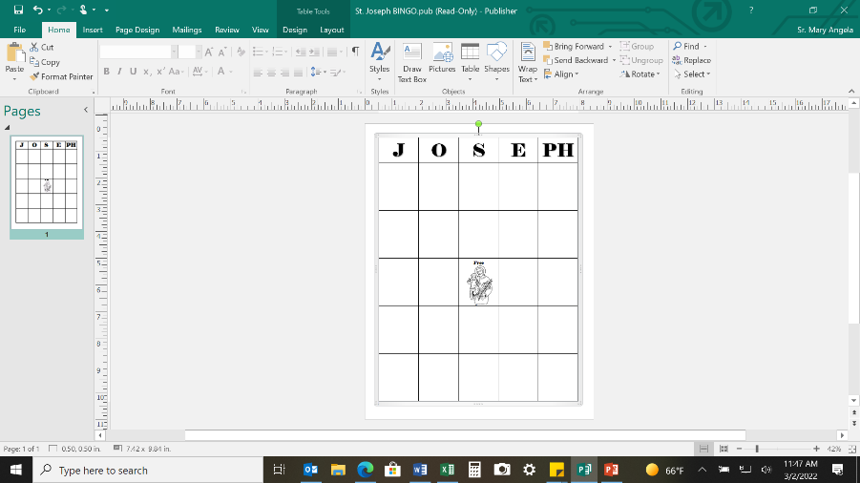**About 9:15-9:45: All School Bingo game on the intercom**! Classes will pair up in buddies and Mr. Naumann will call Bingo on the intercom. There will be directions for what type of Bingo, such as 4 Corners, etc. We plan to use ***J-O-S-E-PH*** instead of B-I-N-G-O for the letters. Once a student gets a Bingo, they will go to the office or designated area to receive a token prize or candy. **Buddy Grades for Bingo**: Preschool & 5th; 1st & 8th; K & 7th; 2nd & 4th; 3rd & 6th
* **Staff Potluck Lunch**
* **Popcorn treats**: Student Council will again deliver sacks with popcorn for a snack!   
  Thank you, StuCo!
* **Movies/Activities**: Classrooms have an option of watching St. Joseph videos or doing other planned activities such as playing a board game or an arts and craft activity.
* **Mission Carnival**: 11:30 am to 2:30 pm – Grades sign up for 20 min. time slots, hosted by Student Council to support the people of Ukraine. **See below for more details.**
* **Benediction 3:00:** All school attend.



Happy St. Joseph Feast Day!

**Mission Carnival Details**

As part of festivities we will be having a Mission Carnival hosted by the Student Council in the gymnasium from 11:30 am–2:30 pm. All are welcome to attend! Our proceeds this year will go to support the people in the Ukraine. The money we collect will help missionaries there to provide food, clothing, blankets, medical supplies and other basic needs for our brothers and sisters who are in need because of the war.

Monsignor Harrington, who visited our school in December, was in the Ukraine last April during Holy Week. The short [**video clip**](https://www.youtube-nocookie.com/embed/aZ5TeeQu724?playlist=aZ5TeeQu724&autoplay=1&iv_load_policy=3&loop=1&modestbranding=1&start=) he made gives us brief a view of the loss of life and devastation the country has sustained. The Student Council will begin collecting money on March 13-20. Students may bring the money and give it to the classroom teacher. Our goal this year will be to collect $5,000 dollars! During this Season of Lent let us open our hearts to prayers, fasting and almsgiving to those most in hardship and want.